**Region-Growing Segmentation Implementation & Comparison Project**

**Team member:** LI HUANG – graduate student

**Abstract**

Region growing segmentation have been widely used especially in the medical area. However, the problem with it is the selection of initial seed points would affect the accuracy of the segmentation results. In this paper, I have implemented three seed selection algorithms and compared the segmentation results based on one lung CT scan image. All of them have achieve great segmentation results, even the seeds selected are different, and the process and required working time is very different, as describe in the conclusion.

**Introduction**

Image segmentation is the process of partitioning an image into several homogeneous regions by classifying all pixels in the image into different clusters that exhibit similar features [1] (eg. Color, texture, edges), which means that adjacent pixels in the same region have similar visual features. Algorithms of region based segmentation tries to determine the region segmentation directly by grouping pixels in an image into different regions. This grouping process starts with a seed point, which is known as seeded region growing.

Seeded region growing has the advantage of specifying just one interested region by placing a seed inside it. However, the performance of SRG algorithms depends on this position. The problem with seeded region growing is selecting the starting seed, as the initial seed would affect the accuracy of the segmentation results [2]. For example, if a seed point is selected outside the region of interests, the final segmentation result will be definitely incorrect.

Good image segmentation should meet certain requirements[3]: Every pixel in the image belongs to a region, Each region is homogeneous with respect characteristics

and No regions overlap.

**Related work**

There are many automatic seeded region growing system developed to solve the problem of selection of seed points, both for color image and gray image. Basically, the current works are performed by extraction of the regions by using a segmentation technique then the selection of seeds inner these regions by pixel features.

For example, Jianping Fan et al. proposed a new automatic image segmentation method[2]. Color edges in an image are first obtained automatically by combining an improved isotropic edge detector and a fast entropic thresholding technique. After the obtained color edges have provided the major geometric structures in an image, the centroids between these adjacent edge regions are taken as the initial seeds for seeded region growing (SRG)[2]. The results are also compared with several other well-known isotropic edge detectors. A new automatic image segmentation algorithm is proposed in this paper, and the evaluation is based on 4 random images. The paper would be more convicing if more evaluation images and quantitative evaluating methods are applied.

Frank Y.Shih et al. suggest selecting seed if the seed satisfies[4]: The seed pixel must have high similarity to its neighbors; For an expected region, at least one seed must be generated in order to produce the region; Seeds for different regions must be disconnected. In this paper, they present an automatic seeded region growing algorithm for color image segmentation. First, the input RGB color image is transformed into YCbCr color space. Second, the initial seeds are automatically selected. Third, the color image is segmented into regions where each region corresponds to a seed. Finally, region-merging is used to merge similar or small regions. They performed experiments successfully using the proposed segmentation algorithm on 150 color nature

scene images randomly collected from the Internet. Experimental results show that their algorithm can produce good results compared to 2 algorithms developed by other people, the results are less noisy and produces more detailed and accurate boundaries. They also pointed out the disadvantages in their algorithm and comparison results with other algorithms. However, this comparison is not shown quantitatively by data in this paper.

Ikonomakis et al. propose[5] presents a seeded region growing and merging algorithm that was created to segment grey scale and colour images. The approach starts with a set of seed pixels and from these grows regions by appending to each seed pixel those neighbouring pixels that satisfy a certain prcdicate. Small regions of far away values were merged to neighbouring regions while regions of similar value were also merged. Homogeneity functions are introduced for both grey scale and colour images. First pixel of the image is considered as the seed pixel. This seed pixel is compared with the all the 8-neighbouring pixels and which satisfies the predefined homogeneity function is grouped to the first region and its pixel value is changed as that of the seed pixel. This neighbor comparison step can be repeated for every new pixel assigned to the first region until the region is bounded by the edge of the image or by pixels that do not satisfy the homogeneity function. The next seed pixel for the second region is determined by choosing the first unassigned pixel. The images used are 2 image ‘airplane’ and ‘claire’, but the authors did not specify the source of the images and how it is chosen. The paper examined a region growing and two region merging techniques. These region-based segmentation techniques are examined on both grey scale and colour images.

In the study of Al-Faris et al. on MRI breast segmentation[6], the approach started by automatic selection for the suitable threshold value. The algorithm searches for the maximum value in each row in the image and calculate a summation and mean maximum raw, which is the threshold value for the binarization process. And then applying morphological open operation to smooth the image and to enhance the boundary of the suspected regions. The highest region’s density value will be chosen as the main suspected region. Seed is the pixel of the main suspected region with maximum intensity value. The algorithm is applied and tested on 40 test images from the RIDER breast MRI dataset, the results are evaluated in comparison to the ground truths of the dataset. The analysis of variance (ANOVA) test shows that there is a statistically significance in the performance compared to the previous segmentation approaches that have been tested on the same dataset.

Shan et al.[7] developed a seed selection process as: reduce speckle, select iterative threshold, delete the boundary-connected regions, rank the regions and determine the seed point. The advantage of this paper is they also compared their results with others’ and provide a balance evaluation. By the evaluation of seed position as near the center of region, near the inside boundary of region or outside the region. The method is validated on our database with 105 ultrasound images with breast masses and it is compared with other automatic seed point selecting method on the same database. The results show that the method can successfully find the proper seed points for 95.2% of the US images in the database which is much more robust than other automatic seed point selection methods. And the paper could be improved by test and compare the final segmentation results based on the seed selection.

**Methodology**

**Region-Growing based Image Segmentation Flow chart**

Figure Region Growing Segmentation Structure

The objective of this paper is to design and create a region-growing segmentat­­ion system to segment an image. A problem in region-growing algorithm is the choose of the starting point. I will be using 3 ways to choose seed point, implement the algorithms, output the segmented results and compare.

* User domain knowledge based seed selection

Selecting seed point using high-level knowledge of semantic image components would fully exploit the advantages of seeded region growing, as the selection of seed is meaningful for accurate region growing to form an region as required from an expert.

* Histogram based seed selection

First, histogram of all the pixels are calculated and different clusters are formed according to different peaks; identify the peaks points as the starting points.

* Clustering-based seed selection

Use K-means clustering to determine how many clusters in the image, and then consider the center of the cluster to be the starting points.

Each pixel is represented by three variables, gray level intensity, coordinate x, coordinate y, perform k-means clustering on the three variables and form k-clusters, we are trying to achieve a status that each cluster would be corresponding to a segmented part in the image.

A problem with k-means clustering is it is sensitive to noises, and thus the noise in the image will be influencing the results. that is why we need to preprocess the image using a median filter.

**Algorithm- Region Growing**

Region growth is done by comparing the seed pixel with all the neighboring pixels/region with a threshold and pixels which satisfy the threshold are grouped to form a single region. The region growing process is done till all the pixel values are grouped in any one of the region.

From a seed point I(x,y), I grow the region by comparing the difference between the seed point and its 8 neighbors, if the difference is within a certain predefined threshold, if TRUE, I add the neighbor into the region and update the region mean, and add the TRUE neighbor into list of points to check further; if the difference is more than a certain predefined threshold, I add the FALSE neighbor into checked list and no further checking is needed. And then we go back to the new list of points to check, repeat the process, until it reached a stable status or I have checked all the pixels in the image. Return a matrix with the region area as TRUE and the rest as FALSE. Then we could display the segmented image based on the Boolean matrix.

The image used is from diagnostic contrast enhanced CT scans images from LIDC image database: LungCT. Link: <https://wiki.cancerimagingarchive.net/display/Public/LungCT-Diagnosis#8df09bd28a384726a250086a0fbe7a94>.

Based on the information of the Representative Tumor Slices specified in the data source, I experiment on one 'R_036_33.dcm' for the three different seed point selection algorithm and compare the segmentation results in this paper.

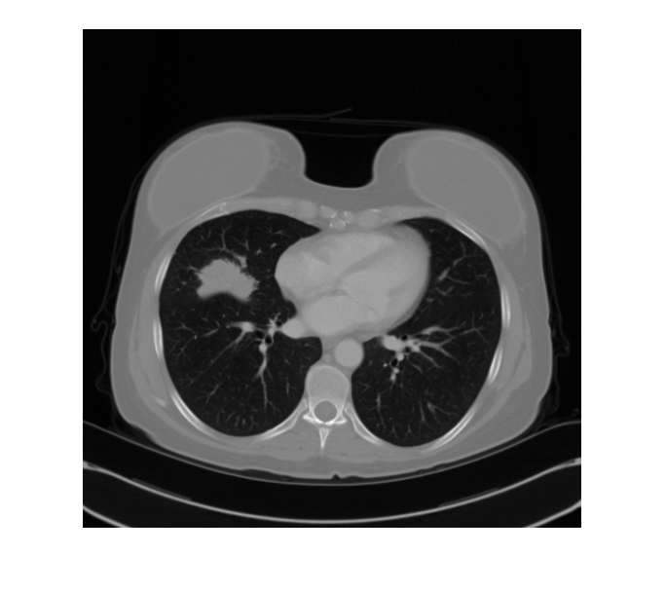 *Figure 1-0: original image*

**Preliminary Results**

**original and smoothed image**

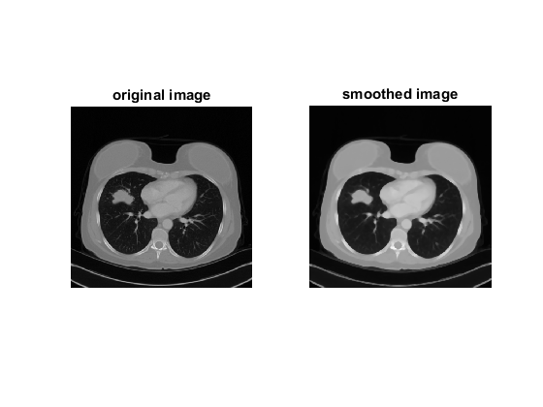 Figure original & smoothed images

* **User domain knowledge based seed selection**

seed selected:

tumor(256,148), left lung(296,152), right lung(327,375), body(271,265)

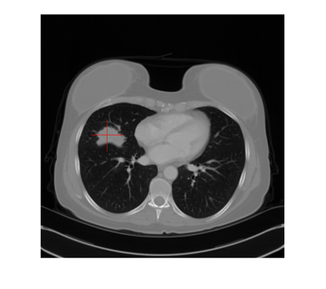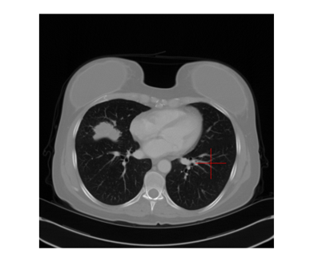

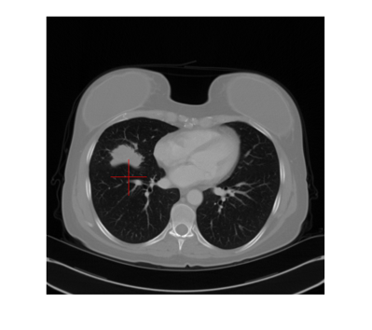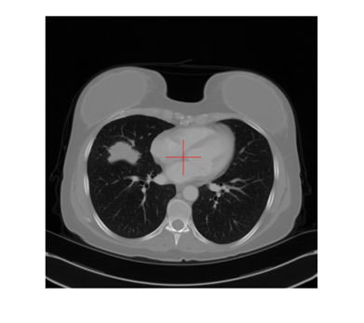 Figure Seed point manually selected

segmentation result:



 

Figure 4 Region Growing Segmentation with manually selected seed: segments

* **Histogram based seed selection**

histogram of smoothed/filtered image new_I:

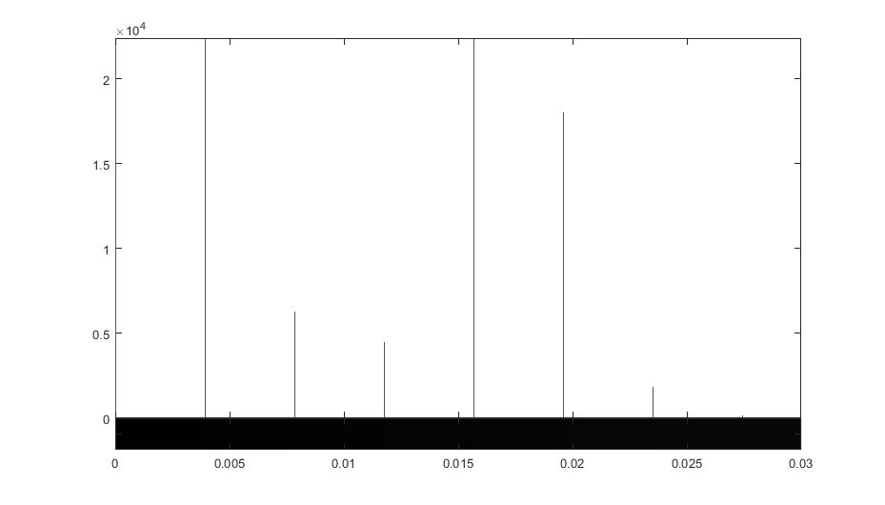

Figure 5 histogram of smoothed image new_I

B3=255*((new_I>0.01)&(new_I<=0.02)); imshow(B3);

B3=255*((new_I>=0)&(new_I<0.01)); imshow(B3);

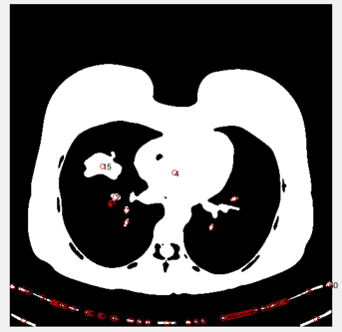

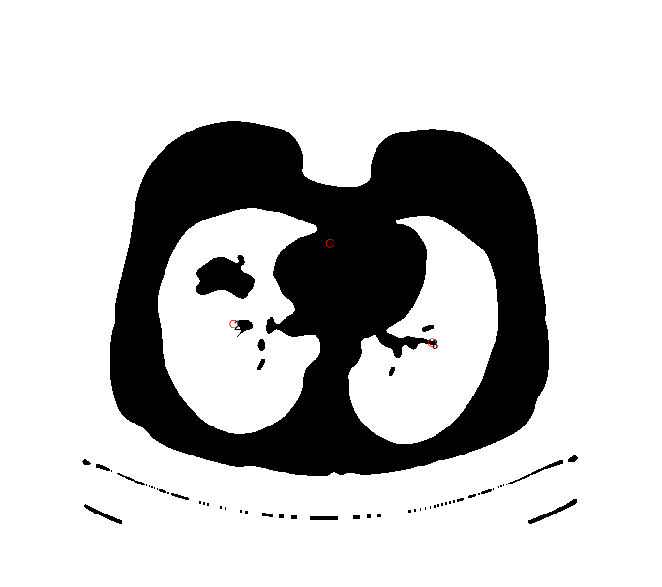

Figure 6 center of regions from histogram thresholding

seed selected:

tumor(148,258), body(262,268), left lung(157,306), right lung(362,365)

segmentation result:





Figure 7 Region Growing Segmentation with seeds from histogram based thresholding: segments

* **Clustering-based seed selection**

seed selected:

K=5

(403,374) (352,277), (109,354), (262,69), (136,262)

segmentation result:



Figure 8 Region Growing Segmentation with clustering selected seed: segments with k=5

seed selected:

K=6

(119,392) (352,276) (396,89) (397,396) (136,261) (117,101)

segmentation result:



Figure 9 Region Growing Segmentation with clustering selected seed: segments with k=6

**Results**

* comparison of the position of seed point: inside-center; inside-boundary; outside

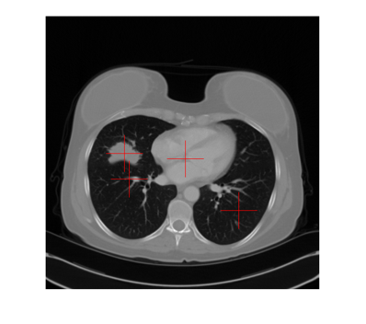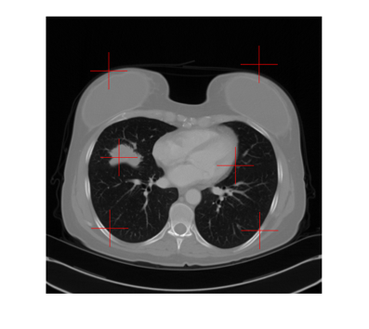

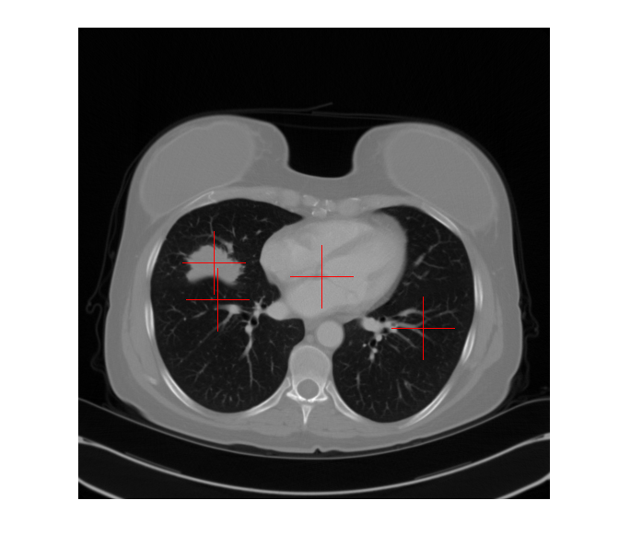

. Figure 10 From left to right: high-level knowledge based seed selection, histogram based seed selection, clustering based seed selection with k=6

* comparison of the segmented image: if there is overlap between the two parts.

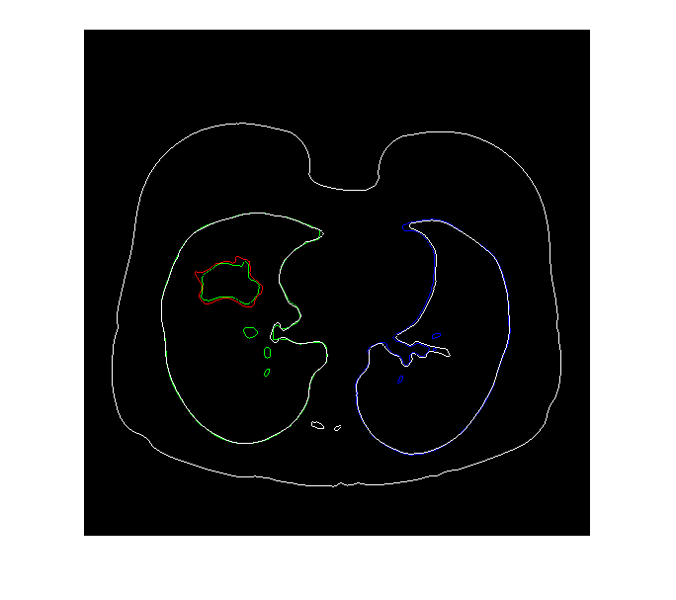 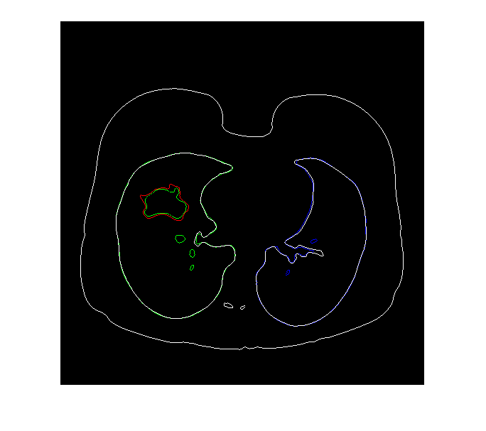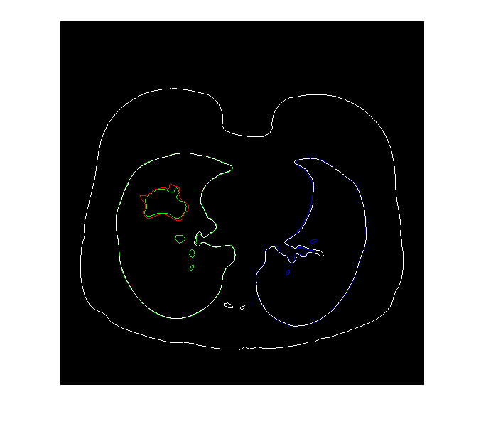

*Figure 11 From left to right: Region Growing Segmentation with edges from manually selected seed, histogram thresh holding selected seed and clustering selected seeds. Edge color in white: body; red: tumor; green: left lung, blue: right lung.*

**Results Evaluation**

The three seed-selection algorithm leads to similar results for segmentation on the image. And the segmentation results are good with very little overlap between different regions. However, the clustering based seed selection is automatically efficient, without extra efforts from human to assist in the seed selection. While high-level knowledge based algorithm require the most efforts from human to input the selected seeds, histogram thresh holding based algorithm require human to identify the center of region after thresh holding on the original image.

The problem with high-level knowledge based algorithm is that it expects initial seeds selection is from an expert in Lung cancer CT image, however, this is not the case when I am processing it. I have a hard time to choose one image that definitely looks abnormal and I can identify which part is abnormal. That is why the image is chosen in this paper.

The problem with histogram based seed selection algorithm is that histogram thresh holding only differentiate intensity level values instead of region/object. That is why the thresh holding results may include more than one region/object, and we have to manually locate the center as there are multiple objects/region in the thresh holding results.

The problem with clustering based seed selection is to decide the k, as if k is too small, the segmentation would not be able to capture all the different objects in the image; and if k is too big, it would cost extra time for the segmentation process. In this case, I have initially tried k=5, it turns out missing one object in the segmentation results; and when I increase k to 6, the segmentation results captured all the objects/parts in the image, with one duplicated parts.

In future research, statistical evaluation of segmentation could be introduced into the comparison like percent lover lap, variability index.

**Conclusion**

We have implemented three algorithms to choose initial seeds in region growing segmentation, even though the initial seeds selected by clustering based algorithm are not necessarily in the center of the region as the other two algorithms, the segmentation results reached similar effect. The position of the initial seeds does affect the segmentation results, but since we have smoothed the image to reduce noises and the seeds are not outside of the region, the results are still satisfying.

My research is mainly implementation based and the comparison of different algorithm is based on one image given the fact that high-level knowledge based seed selection require knowledge about lung cancer and require selecting the initial seeds one by one visually and manually. Possible future research direction could include: Increase high-level knowledge on lung CT scan image; Automatic the histogram thresh holding based seed selection; Test the algorithm on more images to formalize a quantitative comparison; Include color-image region segmentation technique for seed selection.

**References**

[1] Luis Garcia Ugarriza, Eli Saber, Sreenath Rao Vantaram, Vincent Amuso, Mark Shaw and Ranjit Bhaskar, "Automatic Image Segmentation by Dynamic Region Growth and Multiresolution Merging," IEEE Trans. Image Process., vol 18, No 10, pp 2275-2288, Oct 2009

[2] Jianping Fan, David. K.Y.Yau, Ahmed. K.Elmangarmid, and Walid G. Aref, " Automatic Image Segmentation by Integrating Color-Edge Extraction and Seeded Region Growing," IEEE Trans. Image Process., vol 10, No. 10, pp 1454- 1466, Oct 2001

[3] Keri Woods, "Genetic Algorithms : Colour Image Segmentation Literature Review", July 2007

[4] Frank Y. Shih and Shouxian Cheng, "Automatic seeded region growing for color image segmentation," Science direct, Image and vision computing 23(2005) 877-886

[5] N. Ikonomakis, K.N. Plataniotis, M. Zervakis, and A.N. Venetsanopoulos, "Region Growing And Region Merging Image Segmentation," Proceedings Of IEEE Conference On Digital Signal Processing 1(1997) pp 299-302

[6] A.Q. Al-Faris, N. Umi Kalthum, N.A.MatIsa, and I.L. Shuaib, Computer-Aided Segmentation System for Breast MRI Tumour using Modified Automatic Seeded Region Growing, (BMRI-MASRG)”, J Digit Imaging Vol 27, pp 133–144, 2014.

[7] shan J,Cheng HD, WangY. novel automatic seed point selection algorithm for breast ultrasound images. 19th international conference on pattern recognition. 2008:1-4

[8] M. Mary Synthuja Jain Preetha, L.Padma Suresh, MJohn Bosco,," Image Segmentation Using Seeded Region Growing,.", 2012 International Conference on Computing, Electronics and Electrical Technologies